Chapter 2

The role of fire in the dynamics of Piedmont vegetation
Ecoregions: 45, Piedmont; 64, Northern Piedmont
Joanna Spooner¹, Robert K. Peet², Michael P. Schafale³, Alan S. Weakley²
and Thomas R. Wentworth⁴.

¹Environment, Ecology and Energy Program, University of North Carolina, Chapel Hill, NC 27599-3275
²Department of Biology, University of North Carolina, Chapel Hill, NC 27599-3280
³North Carolina Natural Heritage Program, 1615 Mail Service Center, Raleigh, NC 27699-1615
⁴Department of Plant and Microbial Biology, North Carolina State University, Raleigh, NC 27695-7612
Abstract
The Piedmont ecoregion of the United States stretches from New Jersey to Alabama, nestled between the Coastal Plain and Blue Ridge Mountain physiographic provinces. Many of the notable Piedmont plant communities, including the dominant oak-hickory forests of the region, are reliant upon fire to some degree. Before human settlement, most Piedmont vegetation burned relatively frequently and at low intensities, resulting in extensive closed-canopy oak-hickory forests, studded with patches of open woodland and savanna largely defined by unusual soil conditions. Indigenous peoples of the Piedmont used fire as a land management tool for both agriculture and game production. Historical changes in land use throughout the region have altered fire regimes and changed forest dynamics dramatically over the past 400 years. Euro-American settlement led to widespread clearing of land for agriculture and logging; by the early 20th century, very little old-growth forest remained in the Piedmont. During the mid-20th century, the decline of agriculture and the aggressive suppression and exclusion of wildfires brought about the growth of successional forests in the place of older, fire-mediated communities. The Piedmont region is currently experiencing a rapid expansion of the human population and land development, making restoration of the historical fire regime a challenge. However, land managers frequently do use prescribed fire to enhance timber land and restore rare plant communities.
2.1 Introduction
When ecologists consider the vegetation of the Piedmont region of the southeastern United States, they typically reference either the Pine-Oak forest region as described by E. Lucy Braun (1950) or the mosaic of successional pine and mature oak-hickory climax forests described by such eminent early ecologists as Billings (1938), Oosting (1942), and Wells (1932). The perception of the region as originally dominated by oaks and hickories dates back to at least Harshberger (1911) and Weaver and Clements (1929). All of these authors pointed out that mature, old-growth forest was essentially nonexistent in the region by the late 1800s, owing to the long history of land use by Euro-American settlers, with virtually all the land either developed or in some stage of “recovery” from past land use. Indeed, the early and widely cited research of these pioneering American ecologists on succession following land exploitation and abandonment made the Piedmont the model system for the study of secondary forest succession, as epitomized by the work of Keever (1950). Interestingly, there is virtually no mention of fire in those early papers aside from references to its occurrence in successional pine stands, and earlier authors broadly accepted oak-hickory dominance as characteristic of the mature forests of the region. The more recent recognition across the eastern hardwood forest region of North America of the declining abundance of the presumed climax dominant oaks and hickories and their ongoing replacement by “mesophytic” species, such as red maple (Acer rubrum) and beech (Fagus grandifolia), has brought about a significant rethinking of the role of fire and other forms of disturbance in the region (e.g., Abrams 1998, 2003). Collectively, we are beginning to accept that fire was an important driver of community dynamics in the pre-settlement landscape of the Piedmont, and that its importance continued into the early twentieth century. Having now experienced a century of fire suppression and exclusion, ecologists are beginning to rethink the past role of fire in the Piedmont region as a means to informing future management. This reconsideration of the role of fire is especially important if we wish to retain or restore the original character of some of these forests. In this chapter we explore what we know about the past role of fire in maintaining Piedmont vegetation and how we might manage it in the future to restore and maintain the natural vegetation of the region.

2.2 The Piedmont landscape and contemporary vegetation
2.2.1 Geomorphology, soils, and climate
The Piedmont has long been recognized as a distinct physiographic region of North America, being a non-mountainous remnant of the ancient Appalachian upland. Although there are multiple published delineations of the boundaries of the Piedmont, they are largely consistent with only minor differences. The Piedmont stretches from eastern Alabama in a broad arc northeastward to its terminus at The Palisades of New Jersey. Its southeastern boundary is the fall zone (or fall line), where the highly eroded remnants of the ancient igneous Appalachian uplands disappear below the relatively level, younger sedimentary substrates of the Coastal Plain. To the northwest, the Piedmont is bounded by the Blue Ridge Escarpment of the Appalachian Mountains. The U.S. Environmental Protection Agency (EPA) recognizes two subdivisions of the Piedmont in its Level III delineation of ecoregions of the USA (U.S. Environmental Protection Agency 2013). The more southern and much larger of these subdivisions is Ecoregion 45 (Piedmont, which we here call southern Piedmont to avoid ambiguity), extending from eastern Alabama to its terminus near Washington, DC; this ecoregion is the principal focus of this chapter. The Piedmont continues northeastward from northwestern Virginia through Pennsylvania to New Jersey, where it is recognized by EPA as a separate Northern Piedmont Ecoregion (Ecoregion 64). This ecoregion is narrower and has a cooler, drier climate than that of Ecoregion 45, with vegetation that bears a closer resemblance to that found in the Appalachian region to the west. Although we focus on the larger and more distinctive southern Piedmont, much of the Northern Piedmont ecoregion has a broadly similar pattern of vegetation and fire history.
Although the Piedmont consists of a heterogeneous mosaic of ancient terranes assembled during past continental collisions, the region now has relatively uniform topography. The Piedmont is a dissected low plateau, with narrow stream valleys lacking natural impoundments (aside from beaver ponds), broad flat ridges, and isolated areas of higher topography that are erosion-resistant remnant hills (monadnocks). This relatively gentle topography produces broad interconnected areas where fires may have once spread freely, but it also provides many protected slopes and mesic areas that may have experienced less frequent fire of lower intensity.
Most of the Piedmont’s geologic substrate is felsic metamorphic and igneous rocks, such as mica schist, felsic gneisses, granite, rhyolite, and related rocks. A minority of the Piedmont is underlain by mafic rocks such as mafic gneisses, gabbro, diabase, and basalt, often in the form of narrow dikes, but in a few areas consisting of larger plutons or extensive sills. The relative proportion of mafic substrates increases in Virginia and northward. A portion of the area is also sedimentary rock, primarily Triassic age shale, sandstone, and siltstone deposited in rift valleys formed during the separation of the modern-day land masses of Africa and North America (Horton & Zullo 1991). These Triassic basins occur from South Carolina through the Northern Piedmont, where they are more prevalent and make up nearly half of the underlying bedrock.
Most Piedmont soils are Ultisols, consisting of highly leached surficial deposits that developed in place through weathering of the predominant felsic rocks under millions of years of warm, moist climate. Most soils are infertile and strongly acidic, with a loamy topsoil over kaolinitic clays of characteristic red color. Inceptisols and Entisols are present in alluvial areas and in limited rocky sites with weathering-resistant parent rock. Soils derived from mafic rocks have higher base saturation and circumneutral pH, and some are classified as Alfisols. Such mafic rocks sometimes weather to form montmorillonitic clays that confer shrink/swell properties such that the surface can be saturated for extended periods while the subsoil remains extremely dry. In general, the underlying rock and its influence on soils is an important driver of patterns of flora and vegetation across the Piedmont.
Piedmont climate, often classified as humid sub-tropical in the Köppen scheme, has hot, humid summers and cool, mild winters. The broad latitudinal span of the Piedmont results in a range of average temperatures across the region, with annual means ranging between 13° and 17° C. What prevents this region from supporting semi-evergreen broadleaf forest is the occasional deep freeze with average annual minimums generally -10° to -15° C, but occasionally much lower. Precipitation tends to be distributed evenly throughout the year with annual accumulations averaging around 1,200 mm, and ranging from 1,080 to 1,650 mm. Interannual variations in temperature and precipitation are less extreme than those characterizing more continental climates west of the Appalachians.
2.2.2 Current Piedmont vegetation
Upland dry to dry-mesic forests are the most extensive natural vegetation types currently found in the Piedmont, occurring on both the common acidic soils and most of the rarer circumneutral soils. Piedmont forest composition and structure have been greatly affected by a century of chronic fire suppression, and therefore even modern forests with relatively few human impacts do not necessarily reflect historical vegetation patterns. In areas least altered by humans, most of the present vegetation is closed-canopy forest with limited shrub and herb layers owing to the infertility of the soils (Hakkenberg et al. 2020). The canopy is dominated by several oak (Quercus) species and a scattering of representatives of other genera that vary in abundance with edaphic and moisture characteristics. Throughout the Piedmont region and in a wide variety of forest subtypes, white oak (Q. alba) makes up much of the canopy and black oak (Q. velutina) is also abundant. Dry-mesic sites include abundant northern red oak (Q. rubra), while drier sites often include southern red oak (Q. falcata) or post oak (Q. stellata). Chestnut oak (Q. montana) and scarlet oak (Q. coccinea) typically occur in rocky areas such as erosional remnants (monadnocks) and become more important in the Appalachian foothills of the upper Piedmont and northwards. Several species of hickory (primarily Carya tomentosa, C. glabra, C. carolinae-septiontrionalis, and C. ovalis) can be a component of the canopy. Modern Piedmont forests include some tree species that were traditionally considered mesophytic, with red maple now widespread and American beech relatively abundant on dry-mesic sites.
E. Lucy Braun (1950) included Piedmont forests in her “Oak-Pine Forest Region,” which she saw as an eastern “lobe” of the great central oak-hickory forests; however, the abundance of pines (Pinus spp.) varies widely in Piedmont forests. Much of the impression of pine abundance comes from the widespread early successional forests found on abandoned fields and logged areas. In less altered forests, pines may be absent entirely or present only in small to moderate numbers. In North Carolina and northward, the most common pine species of mature forests is shortleaf (Pinus echinata); southward, loblolly (P. taeda) can be a component of mature forests. Over most of the region, pines constitute a small component of the mature, less-altered forests, but one that increases in abundance southward. Near the fall zone from central North Carolina southward, woodlands of longleaf pine (P. palustris) or mixes of longleaf, loblolly, and shortleaf pine replace the prevailing oak forests. These natural Piedmont pine forests experience less fire as compared to the longleaf-dominated woodlands that once dominated much of the adjacent Coastal Plain, and most typically contain several upland oaks as co-dominants (usually chestnut oak and blackjack oak) (Stokes et al. 2010, Patterson & Knapp 2016). The grassy herbaceous layers of these eastern Piedmont pine woodlands are usually not as well-developed as those found in longleaf savannas in the Coastal Plain, and a denser shrub layer is often present. When fire is excluded, these pine woodlands succeed to forests with hardwood dominance (Schafale 2012).
Sourwood (Oxydendrum arboreum) and blackgum (Nyssa sylvatica) are common understory trees in Piedmont forests, occasionally reaching the canopy but never as dominants. Flowering dogwood (Cornus florida) is another common and widespread understory tree, though declining in importance owing to the widespread dogwood anthracnose disease. Red maple, while thus far only an infrequent canopy dominant, is often a dominant understory tree. Where a shrub layer is present, ericaceous genera such as Vaccinium are common;prior to increase in the population density of white-tailed deer (Odocoileus virginianus), Viburnum species were also common understory dominants. Herb layers are usually sparse, with only a few shade-tolerant species frequent, and then usually with low cover. In addition to reduced insolation, the low level of basic cations and typically dry upland soils limit the herb layer cover and diversity (Peet, Palmquist, & Tessel 2014, Hakkenberg et al. 2020); in some places a high population density of white-tailed deer further limits development of both shrub and herb cover.
Areas underlain by mafic rock can be readily identified by a distinctive flora. Forests over shrink-swell clays and associated hardpan soils often include post oak, willow oak (Q. phellos), and/or blackjack oak (Q. marilandica), with lesser proportions of white oak. On base-rich soils, ash (Fraxinus biltmoreana, F. americana) may be abundant, though now greatly reduced by the emerald ash borer (Agrilus planipennis). Hickories may be more common, particularly shagbark hickory (C. carolinae-septentrionalis and C. ovata). Common understory trees in such forests include chalk maple (Acer leucoderme), southern sugar maple (Acer floridanum), redbud (Cercis canadensis), American hop-hornbeam (Ostrya virginiana), and elm (Ulmus alata or U. rubra). Diversity within the herb and shrub layers is often quite high on these less acidic soils, and mafic rock specialists are often present. These forests may include herbs and shrubs more common on mesic sites, or a different set of species that thrive on dry, mafic sites.
Within the matrix of Piedmont oak-hickory forests, a number of open-canopy plant communities can be found associated with unusual edaphic characteristics that preclude closed forest development. These include glades, barrens, granitic flatrocks, and other outcrop communities with varying amounts of bare rock and patchy vegetation. More open communities are also found on areas of montmorillonitic soils, where shrink-swell clays slow tree growth, and on rare areas of serpentine and other ultramafic rock, where extreme soil chemistry is the limiting factor. Edaphically-limited vegetation varies in physiognomy from open-canopy woodlands to patchy grassland to sparse vegetation on rock outcrops. These edaphically-unusual communities are uncommon in the Piedmont, but they receive a great deal of attention due to the presence of rare plant species. Open-canopy plant communities are largely maintained by the unusual substrates of such sites, but fire contributes to impeding the development of a canopy over the long-term. The vegetation of extreme sites grades into the surrounding closed forest of more typical substrates to create a wide range of more open canopies and subcanopies, which allow more sunlight penetration and support heliophytic herbs. Such border woodlands may be fire-dependent, and absence of fire can lead to the development of a denser canopy. Conservation and restoration of these types of open, fire-maintained vegetation have become popular topics for land managers, and these topics will be discussed in Section 4.
Most of the Piedmont’s modern vegetation is successional forest developed after abandonment following agriculture or heavy logging. These successional forests established prior to the twentieth century were typically dominated by the originally widely distributed shortleaf pine. Subsequently, loblolly and Virginia pine (P. virginiana) expanded their ranges and have now largely replaced shortleaf as the dominant pines in newer successional stands. The fire-sensitive tulip-tree (Liriodendron tulipifera) and sweetgum (Liquidambar styraciflua), important successional species in bottomlands, have expanded to become common co-dominants in successional upland forests.
High-severity natural disturbances within Piedmont forests are usually limited in scale to canopy gaps that originate from hurricanes, other types of catastrophic wind events, or ice storms (Peterson et al. 2016, Lafon 2016). Although major storms can produce many canopy gaps, individual gaps are generally small. Gap-disturbance dynamics result in a fine-scale patchwork of different tree ages where concepts such as stand age or successional stage do not readily apply. Local land-use legacies can greatly alter these disturbance dynamics, with agricultural abandonment and intensive logging creating even-aged stands over large areas. Over time, canopy gaps form due to weather events or outbreaks of the native southern pine beetle (Dendroctonus frontalis), allowing the successional forests to gradually regain the mosaic character of mature natural forests (Nowak et al. 2016).
2.2.3 Human development in the 20th and 21st centuries
The modern Piedmont region has a rapidly growing human population. Development of formerly rural areas has resulted in a mosaic of land uses that includes agricultural fields, successional forests, patches of more natural forest, and increasing amounts of urban and suburban sprawl. While larger tracts of forested land do still exist in parts of the Piedmont, nearly all of such forest is less than 150 years old, and primary forest is effectively absent from the landscape.
Ultimately, the modern vegetation we see in the Piedmont is shaped by edaphic, climatic, and other non-anthropogenic disturbance characteristics, but these factors act upon the legacy of centuries of human land-use. To understand current Piedmont forest dynamics, the full scope of history must be taken into account. Historic fire regimes and vegetation are both poorly understood for much of the region, but knowledge of these is becoming increasingly important in making sound land-management decisions.

2.3 Fire and the Pre-European Piedmont Landscape
2.3.1 The prehistoric Piedmont: vegetation and fire
Vegetation change in the Piedmont since the last full glacial (approximately 22,000 ybp) remains poorly understood because there are few lines of evidence. While pollen records can clarify the vegetation history of the glaciated northeastern US and to some extent the southeastern Coastal Plain, the topographically mature landscape of the Piedmont, with its general lack of natural lakes and depressions, has virtually no pollen record. The sandy soils of the Coastal Plain appear to have supported jack pine (Pinus banksiana) vegetation during the full glacial, but this reflects, in part, the nature of the soils. More likely the Piedmont supported a mix of spruce (Picea) and pine, with patches of deciduous forest on more nutrient-rich islands such as occurred on riparian bluffs or on soils derived from intrusions of mafic rock. It is widely accepted that the lower CO₂ content of the full-glacial atmosphere would have favored pyrophytic C₄ grasses; consequently, fire frequency was relatively high in many portions of the world, particularly the subtropics. However, efforts to model the full-glacial abundance of C₄ grasses across North America during the full glacial have led to ambiguous results, so the contribution of increased grass cover to fire in Piedmont vegetation through the end of the Pleistocene (11,700 ybp) remains unknown (Still et al. 2019).
Fossil pollen datasets poorly represent the Southeast; however, they do suggest that the warming, post-glacial climate allowed oaks, pines, hickories, and other hardwoods to migrate northward as Piedmont forests began to more closely resemble the familiar oak-hickory forests of recent history (Williams et al. 2004). The climate remained dry, and lightning-ignited fire was likely a significant source of disturbance in upland areas. The early Holocene Piedmont landscape was naturally less prone to fire than the adjacent Coastal Plain, which had both higher lightning frequencies (Figure 1.1), more extensive pyrophytic vegetation (Table 1.1), and a flatter, less dissected terrain that more easily carried fire over significant distances (Frost 1998; see Chap. 3). In contrast, while fire was frequent on dry ridges in the Appalachians, Piedmont vegetation likely experienced more frequent fire than most of the Appalachian Mountains, where rugged terrain and finer-scale vegetation mosaics restricted fire spread (see Chap. 4).
Prior to human intervention, most riparian forests, wetlands, and mesic, sheltered forests likely burned only rarely and at low intensity. Soil moisture and high humidity allowed the litter and duff layers to remain moist, reducing the chance of fire ignition and spread in all but the most severe drought conditions. The occurrence of mesic forests on slopes, forcing fires to spread downhill, was also an impediment to fire spread, while the removal of litter by floods and the interspersion of wet sloughs would have had a similar role in floodplains. The dominant trees of mesic forests, such as beech, southern sugar maple (A. floridanum), and bottomland hardwoods were, therefore, able to persist despite their relative fire intolerance. It is clear that bottomlands did occasionally burn, however, because canebrake communities were once present on some of the higher portions of alluvial floodplains (Foote 1846). Canebrakes are disturbance-dependent, monodominant communities of cane (Arundinaria spp.), historically maintained by fire (Gagnon 2009; see Chap. 6). Fires in bottomland forests were likely the result of a confluence of weather events: a storm would create a canopy gap, allowing dense understory vegetation to develop, then a period of drought would dry out this additional fuel and allow for fire spread after a lightning ignition (Gagnon 2009). In general, however, mesic and bottomland vegetation likely acted as a natural fire break, limiting fire compartment size in the Piedmont. Nevertheless, the apparent occurrence of frequent past fires in the Piedmont uplands suggests that fires must have been able to occasionally cross such areas to continue spreading widely across the landscape.
a. 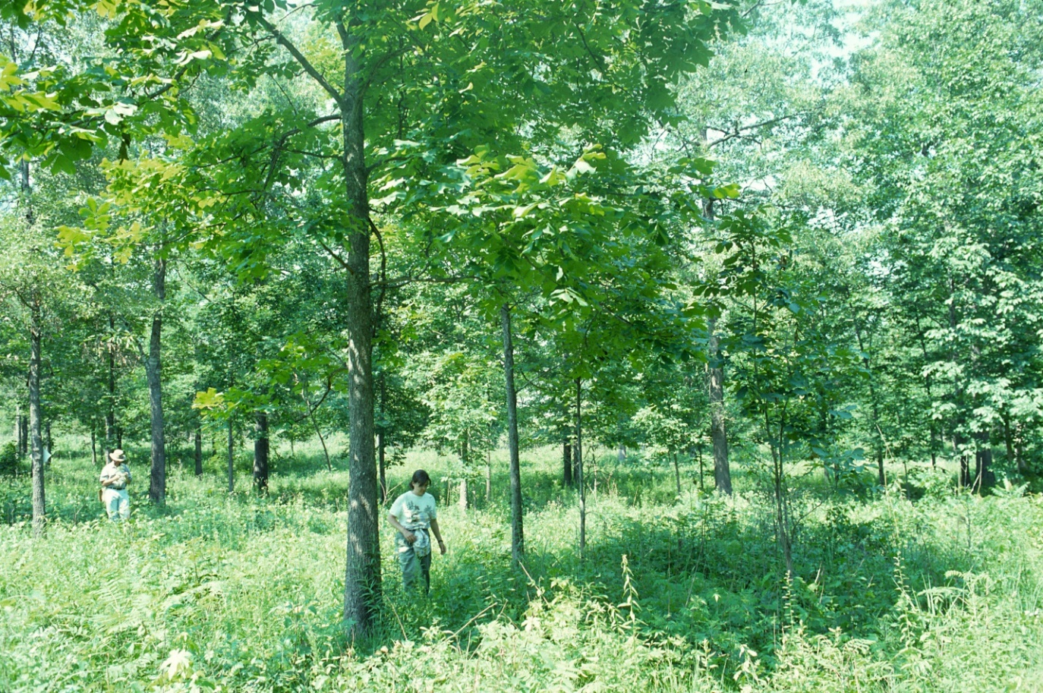

b. 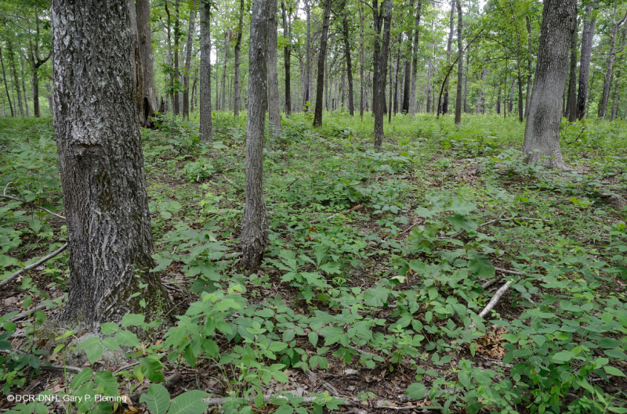
Figure 2.1. Two examples of open-canopy oak woodland from the Piedmont, both from Army National Guard Maneuver Training Center-Fort Pickett, Virginia. This vegetation has been maintained by frequent, low-intensity surface fires every 1-3 years since 1942, ignited by live-ammunition training exercises (Emrick & Jones 2008). Though this frequency of fire is likely more extreme than in most parts of the presettlement Piedmont, this type of vegetation is presumed to have been more common in the landscape when fire was a common disturbance. The widely spaced, uneven-aged, canopy trees in (a) allow for a diverse herbaceous layer of grasses and forbs (photo copyright Robert Peet). Additional canopy cover is present in (b), but with less understory tree regeneration. The mixed grass-forb understory has been replaced by one dominated by a variety of legumes (Fabaceae) and hardwood seedlings (photo copyright Gary Fleming).
Upland areas were affected more substantially by fires. Due to the high humidity of the region and moderate flammability of oak litter, the fires in upland Piedmont oak forests were generally low-intensity surface fires. Presettlement oak forests are believed to have had a more open canopy than those found in the modern Piedmont, allowing more sunlight to penetrate and resulting in a denser, more species-rich herb layer. The greater abundance of grasses in the herb layer of these more open communities likely allowed fires to burn more intensely than those observed at present. Sites with the most fire generally developed a woodland structure with a discontinuous canopy, open understory, and diverse herb layer (Figure 2.1). Based on landscape and environmental evidence, historical records, and direct vegetation records (such as fire scar analysis), Frost’s analysis (1998) suggests that the most fire-exposed portions of the majority of the southern Piedmont generally burned every 4-6 years, while the Northern Piedmont saw fewer fires. This discontinuity of the fire regime suggests that, like the vegetation, the fire regime of the Northern Piedmont more closely resembled that found in the southern Appalachians. While relatively frequent, Piedmont fires were usually only severe enough to kill fire-sensitive seedlings and consume dry litter, often leaving adult trees completely unscarred.
Trees of upland habitats in the Piedmont have significant adaptations that allowed them to withstand the frequent surface fires that occurred, and to regenerate after fire damage. Acorns and hickory nuts are frequently cached in the soil by wildlife, protecting them from damage by fires. Oak and hickory seedlings invest more energy in root development than shoot development in their early years, in contrast to maples and other more mesophytic species (Brose & Van Lear 1998). While almost all Piedmont tree species readily resprout after being top-killed by fire, the particularly robust root systems of oak and hickory seedlings give them a competitive advantage under conditions of repeated removal of above-ground parts by fires. The abundant shortleaf pine of historical Piedmont forests is more fire-tolerant than loblolly or Virginia pine. A basal “crook” in stems of shortleaf seedlings keeps some dormant buds at ground level, where they are somewhat protected from fire, giving the seedling some ability to resprout if top-killed. Most oaks and many other trees of dry upland habitats also have thick bark that protects the cambium from fire damage. While even mesophytic trees develop thicker mature bark and become relatively fire-tolerant once they reach a larger size class, this happens much earlier in oaks. Finally, oak wood is particularly resistant to rot after fire scarring, allowing trees to survive and heal even after significant fire damage (Abrams 1996).
Low-intensity surface fires in upland prehistoric forests generally did not cause mortality among mature trees and instead had a primary ecological role in recruitment. Repeated fire, especially, can play a crucial role as a filter, influencing which species experience greater seedling establishment, sapling survival, and ultimate recruitment, causing differential survival of larger individuals. Red maple, for example, while more tolerant of fire at larger sizes, is still more susceptible to being killed by fire than most oaks at all sizes. In Piedmont forests, consistent seed rain results in a pool of seedlings in the herb layer “waiting” for a canopy gap to form. Oak and hickory seedlings, with their large nutrient reserves, can persist for several years in the herb layer of relatively open forests, along with more shade-tolerant species. If a canopy gap forms, they may grow quickly, unless they have already been overtopped by other species in the understory. The ability of oak seedlings to resprout allows fire to act as a species filter for seedling establishment, removing seedlings of species such as red maple and enhancing the pool of oak seedlings able to take advantage of canopy gaps (Lafon et al. 2017).
The prehistoric seasonality of fire in the southern Piedmont is not as clearly understood as it is for Northern Piedmont hardwood forests. There, dormant-season fires were historically most common (Knapp et al. 2009), largely owing to the seasonal influx of flammable dead leaves and rapid drying of the forest floor in the absence of canopy cover. Similar factors are likely at play in southern Piedmont forests. The southeastern Coastal Plain has the highest number of lightning strikes in the USA (Orville et al. 2011), and the adjacent Piedmont also has relatively high lightning frequency (Chap. 1, Fig. 1.1). Lightning-strike ignitions peak in the summer months, accompanying summer thunderstorms, but humidity peaks in the summer as well, reducing the spread of any ignitions during wet years. Late summer and early fall may have represented the peak of historical lightning-ignited fires in woodlands, where summer lightning was frequent enough to ignite plentiful grassy fuels. However, occasional thunderstorms, coupled with frequent dry spells in spring, could also have allowed widespread fires. When lightning struck standing deadwood, fires could smolder and rekindle after a storm had passed. Because these snags were usually part of canopy gaps, the grassy understory would have been particularly dense, enabling it to better carry a fire. Precipitation is generally distributed throughout the year in the Piedmont, so the lack of a clear “dry season” means that random periods of drought also had a significant effect upon fire regimes. Such interactions between drought and fire played a significant role in the forest dynamics of southeastern forests (Littell et al. 2016).
₊₊₊
Figure 2.2. Early French map of Virginia and the Carolinas dated 1718, with a large region labeled “Grande Savane” in the western Piedmont of North Carolina. (Guillaume De L’Isle. 1718.)
In addition to its role in forests, fire acted upon a continuum of more open habitats, ranging from woodland to near-prairie. Most of the patches of edaphically-limited vegetation were small, as they are now, and ignitions in the past mostly came from fires in the surrounding landscape. Fire frequency in these communities was therefore similar to that in the surrounding forest landscape. However, fire is more effective in maintaining open vegetation in extreme sites. Extensive grass cover in some of these communities provided contiguous, highly-flammable fuels that facilitated fire spread. While many open areas had specialized vegetation due to edaphic conditions, others appear to have occurred on less unusual soils. Early European explorers described vast regions of what they often labeled “savanna” on maps, usually in the Piedmont of the Carolinas (Figure 2.2). These regions appear to be too expansive to fit the pattern of woodlands seen in the vicinities of Mississippian settlements. Such open vegetation was sometimes described as plains or grassland, but apparently included enough tree cover that the modern use of savanna or woodland would be a more accurate descriptor. However, such maps may or may not be reliable, particularly as a given map may have been based on only a few sightlines and reports from local tribes muddled by a language barrier. These older maps are distorted enough that it is unclear where many of the recorded places were, but no large plains in the modern sense occur in these areas. Because of the unreliability of European maps and reports, the actual existence of extensive savanna or grassland regions in the Piedmont remains unclear. Even the prevalence of smaller regions of open woodland and savanna on non-edaphically limited sites is a matter for debate, because this type of vegetation no longer occurs in the Piedmont.
A couple of interesting lines of evidence support the idea that substantial open-canopy, savanna-like vegetation pre-dated the habitat modification practiced by the Native American inhabitants of the Piedmont. The rich diversity of native heliophyte species in the Piedmont implies a long history of naturally open patches of vegetation. Several characteristic prairie plant genera also occur in the southern Piedmont region. While these plants are not as abundant as they are in the prairie region of the USA, multiple prairie genera have higher diversity of species in the Southeast. The overall herbaceous flora of the Piedmont has a significant proportion composed of species that generally occur in open or semi-open habitat, including many current species of concern at the state or Federal level (Szakacs 2020). The diversity of these heliophytes does not demonstrate that open vegetation occurred in the huge contiguous areas described in early maps, but it does argue that open areas with a diversity of habitat characteristics were widespread and persistant over many millenia. It is unclear how much of this open habitat was in areas with unusual edaphic characteristics, and how much was on more ordinary soil that would support forest in the absence of fire. In addition, enough grassy vegetation must have existed to support the elk and bison reported by many early Europeans on Piedmont plains and savannas from Virginia to Georgia (Beverley 2013, Lawson 1709, Catesby 1771, Barden 1997). However, these reports themselves do not demonstrate the existence of larger savanna regions. Distinct eastern taxa of elk and bison were extinct before they could be studied in detail; these animals may have inhabited more woodland habitats than their Great Plains cousins. Additionally, there is little reliable information about the abundance of such animals east of the Mississippi. It’s possible that elk and bison were relatively recent arrivals in the Piedmont when observed by Europeans, originally drawn east by increasingly intensive land management by Native Americans. Regardless, a natural fire regime was clearly important in maintaining open habitat over the time span needed to accumulate a diversity of heliophytic species.
2.3.2 Early human impacts on the Piedmont
Throughout much of the pre-European history of the southern Piedmont, the human population was relatively small and diffuse, resulting in only minor anthropogenic disturbance. Paleo-Indians migrated to the Piedmont around 11,000 years ago, equipped with Clovis-point technology. Temperatures peaked during the hypsithermal (7,500-5,000 BP), and this warm, dry climate coincided with the earliest recorded effects of anthropogenic fire on the Piedmont landscape. Pines, in particular, expanded their range northward during this period (Williams et al. 2004). Through the Archaic cultural period (8000-1000 BCE), early residents of the region were hunter-gatherers (Turck et al. 2011). Humans began to use fire to maintain habitat for hunting and foraging, though soil charcoal content suggests that the overall landscape-level impacts were minor (Fowler & Konopik 2007). Indigenous people during the subsequent Woodland cultural era (1000 BCE through 1000 CE) generally lived in semi-permanent or permanent settlements in alluvial plains and river valleys, practicing a mix of hunting, gathering, and small-scale agriculture. Populations were densest in these fertile areas where agriculture was easiest to pursue.
Fire was employed for hunting and promotion of game habitat during the Archaic cultural period, but significant environmental impacts likely began only when the Woodland peoples began cultivating domesticated crops in the alluvial plains of the Piedmont (Jones et al. 2012). These groups used fire as an important land management tool to prepare agricultural fields and to promote favorable hunting habitat. Major cultural and technological changes ensued with the arrival of the Mississippian culture around 1000 ybp (Fowler & Konopik 2007). The increasing human population depended upon larger-scale, maize-focused agriculture, which necessitated the clearing of additional forested bottomland areas to provide fertile agricultural fields (Turck et al. 2012). Mississippian peoples made liberal use of fire to shape the landscape to best fit their needs. The burning of agricultural and hunting land likely occurred in the late winter to early spring, preparing fields for spring planting and encouraging herbaceous regrowth to attract game species to woodland areas (Fowler & Konopik 2007). Descriptions of pre-colonial open woodland place much of it near settlements along rivers, which is not a likely site of open Piedmont vegetation, unless maintained by humans. Deliberate fires in riverine areas certainly would have spread to upland areas, but we do not have sufficient evidence to describe the patterns. The prevalence of upland, open vegetation types in the pre-colonial Piedmont remains unclear.
Because early Piedmont peoples did not leave behind a record of their environment, much of our knowledge of early historical vegetation and fire regimes comes from reports by early European explorers. First-hand written accounts of the Piedmont date back to early Spanish explorers in the 16th century. In 1540, Hernando De Soto’s men reported marveling at the open, garden-like nature of the Cofitachequi lands of the outer Piedmont of South Carolina (Hammett 1992). Trees were spaced widely enough to appear deliberately planted, and other European visitors described the easy availability of fruits and nuts. Descriptions of the understories of these woodlands suggest richer herb and shrub layers than what is found in modern forests. Some reports focused on the variety of fruit-bearing plants, and others described grassy forest floors. Plentiful canopy gaps and wooded openings provided additional edge habitat, which in turn supported the game species that humans preferred to hunt. This type of open-canopy, fire-maintained woodland usually surrounded the more intensively planted agricultural fields and residential areas of villages throughout the Piedmont region. Open woodlands thus served as a combination of orchards, hunting grounds, and woodlots.
The Piedmont was usually described by European explorers from the 16th through 18th centuries as a patchwork landscape with a mix of forest, woodland, and savanna. These visitors credited the local inhabitants with clearing and maintaining the open woodland terrain they encountered, usually associating grassy, park-like vegetation with nearby villages. German explorer John Lederer, one of the first Europeans to travel from the Tidewater of Virginia to the Blue Ridge Mountains, describes passing several “savannae” on his way south through the Piedmont of Virginia and North Carolina (Rostlund 1957). He noted land that “by the industry of the Indians was very open and clear of wood,” and, while he found forested land, “where it was inhabited by Indians, it lay open in spacious plains.” While the relative proportions of natural and anthropogenic fires in the Piedmont during the age of early European exploration are unclear, Catesby’s descriptions from his travels in the 1720s of the fires in the interior of the Carolinas suggest annual burns in at least some areas: “In February and March the inhabitants have a custom of burning the woods, which causes such a continual smoke, that not knowing the cause, it might be imagined to proceed from fog . . . . an annual custom of the Indians in their huntings, of setting the woods on fire many miles in extent” (Catesby 1771).
Early European explorers of the Piedmont visited towns and settlements, traveled along trails and roadways cleared by Native Americans, and described land reflecting the heavy human impacts to be found near human habitation. This likely provided an exaggerated view of the extent of anthropogenic open vegetation; it’s unclear how widespread such cleared land was beyond the immediate vicinity of habitation. The plentiful rainfall of the Piedmont is sufficient to support forested vegetation types, and the fact that open habitat apparently persisted in heavily inhabited parts of the Piedmont suggests that anthropogenic fire was a key factor in preventing succession to forest (Barden 1997, Delcourt & Delcourt 2004).

2.4 Fire after Euro-American settlement
With the arrival of Euro-American explorers and settlers in North America in the early 17th century and the subsequent decimation of the Native American inhabitants by European diseases, land use and natural vegetation both began to change. Settlers initially colonized the Coastal Plain, and their westward expansion into the Piedmont was temporarily halted at the fall zone because of the lack of navigable rivers. In the early to mid-1700s, displaced Scots-Irish settlers from the frontier of Pennsylvania began to migrate south along trade roads, settling in the Piedmont of Virginia, North Carolina, and, eventually, farther south. In addition, by this time the population in the Coastal Plain grew sufficiently dense that settlers began to work their way west overland, continuing the gradual colonization of the Piedmont. These Euro-American colonists were small-scale, largely subsistence farmers.
Early Euro-American arrivals preferentially settled on floodplain land originally cleared, cultivated, and ultimately abandoned by the previous Native American inhabitants (Coughlan & Nelson 2018). Initially, many Euro-American settlers mimicked the regular burning methods and shifting agricultural style of the Native Americans (Noss 2012). With draft animals and plows, however, the settlers could also cultivate upland soils that would have been impossibly difficult for the Native Americans to work. Once cleared of forest, land would be farmed for several years before soil nutrients were depleted and productivity declined. Unlike Native American methods of farming, the Euro-American farmers’ tillage relied on the plow, and this technology heavily modified the natural soil structure. In combination with the plentiful rainfall of the Piedmont, intensive ploughing and resulting bare soil between rows of crops led to tremendous loss of topsoil by erosion, estimated by Trimble (1974) to average 24.4 cm in South Carolina and 14.5 inches in North Carolina and Virginia. Cropland would then be left fallow for several years, or even permanently abandoned, during which time classic old field succession toward pine forest would begin
With a need to provide pasture for draft animals as well as for cows and sheep, larger additional areas were cleared. Even areas unsuitable for plowing were used as forest grazing land for hogs and cattle, or they were selectively logged. Iron mills arose in the Piedmont during the 18th century, creating a need for plentiful charcoal to fuel furnaces (Ferguson & Cowan 1997). Charcoal production required a constant supply of local timber, and additional forest was felled to meet this demand (Orwig & Abrams 1994). Large-scale logging was less common in the Piedmont than it was in the mountains or the Coastal Plain due to fragmented land ownership and transportation complexities. Initially, timber transport was limited to areas near navigable waters, but the railroads of the 19th century opened more of the Piedmont and Appalachians to commercial logging by connecting inland forests with coastal ports. By this time, however, large tracts of primary forest no longer existed in the Piedmont, and the mountains became a more appealing target for commercial timber harvest. Smaller-scale logging occurred throughout the post-settlement history of the Piedmont, often exploiting formerly farmed secondary forests.
Fire remained common on the landscape during the 19th century. Grazing land was burned deliberately to encourage fresh spring grass. Deliberate burning of agricultural waste and brush was common and was the source of many wildfires in the Piedmont through the early 20th century (Holmes 1914). Accidental fires were frequently sparked by railroads and commercial sawmills, which together caused the greatest proportion of forest fires in the first two decades of the 1900s. These accidental anthropogenic ignitions far outnumbered lightning ignitions, and they occurred in places where they could rapidly burn through logging slash and abandoned fields. Fuel was generally plentiful during this period, and fire incidence was largely limited only by anthropogenic ignitions (Guyette et al. 2002). In fact, lightning-ignited fires are considered rare enough that other climate variables were used by Guyette et al (2012) to model fire frequency during the settlement and early historical period of the Southeast (1650-1850). During the colonial period, mean fire return intervals on any given 1.2 km² area in the southern Piedmont were estimated to be 2-6 years, while return intervals for the Northern Piedmont were estimated to be 4-8 years (Guyette et al. 2012).
Agriculture eventually affected most of the landscape through the late 1800s, before becoming economically unfeasible due to the poor, eroded, and/or depleted soils of most of the southern Piedmont. Agriculture continued to increase in both intensity and scale until the American Civil War prompted a large wave of agricultural abandonment in the 1860s. A final, broad peak in agricultural land use occurred between 1920 and 1940 in the Southeast (Waisanen & Bliss 2002). Agricultural fields were ultimately abandoned following this final wave during the early 20th century in favor of more technology-dependent farming in the Midwest. Abandoned agricultural land underwent secondary succession throughout much of the southern Piedmont, while urban and suburban development exploded toward the end of the 20th century.
Catastrophic wildfires in the western states in the late 19th and early 20th centuries ultimately led the U.S. Forest Service to institute policies to help prevent and quickly contain all wildfires, whether anthropogenic or otherwise. While the low-intensity fires of the Southeast were not as much of a threat to human life and property, they were included in the 1934 Forest Service goal of total wildland fire suppression (Van Wagtendonk 2007). Once this policy was in place, much of the southern Piedmont landscape was effectively fire-free for the subsequent 80+ years. The early part of this period coincided with the time of large-scale agricultural abandonment and rapid development of successional pine forests.
While early ecologists saw oak in the understory of successional pine forests and believed it would reassert dominance over time, the decades of fire suppression favored more shade-tolerant trees, such as red maple, in the understory. Ongoing logging and other forest disturbances greatly enhanced the seed rain of species with ruderal traits, including tulip-tree and sweetgum, as well as red maple. As successional pine stands were logged or aged and began to decline, species more shade-tolerant than oaks replaced them. Such changes also affected forests that had not been cleared. Land surveys of the Georgia Piedmont in 1801-1804 reported forests composed largely of various unspecified pines, post oak, and black oak (Cowell 1995). Modern resurveys of mature forest in the same region of the Georgia Piedmont found a shift from post and black oaks to white oak, a significant decline in pine, and substantial increases in tulip-tree. However, white oak is now seen to be decreasing across its range (Abrams 2003).
Throughout the Piedmont region, tree reproduction has shifted away from xerophytic, fire-tolerant tree species toward mesophytic, fire-sensitive species. While the term “mesophication” was coined fairly recently (Nowacki & Abrams 2008), the pattern of decreasing oak and hickory recruitment and increasing importance of mesophytic hardwoods (Figure 2.3) in Piedmont forests has been noted for quite some time (e.g., Christensen 1977, Peet & Christensen 1980). Christensen (1977) suggested that the dramatic increase in red maple was a natural result of an increasingly shady late-successional forest understory. Fire exclusion and suppression, however, appear to be the major drivers of these changes (Abrams 1992, Nowacki & Abrams 2008).
a. 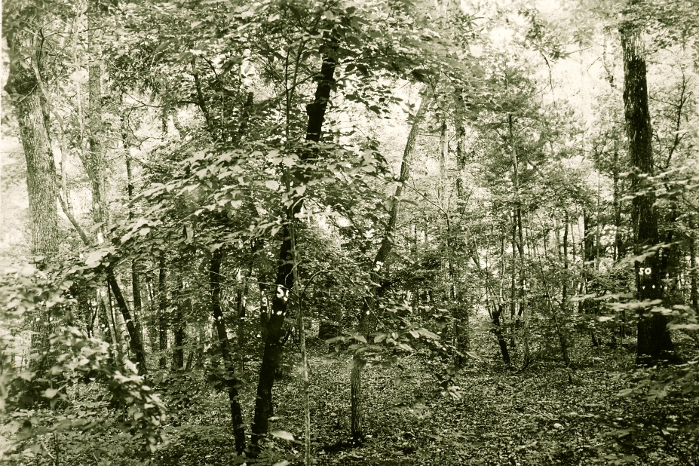
b. 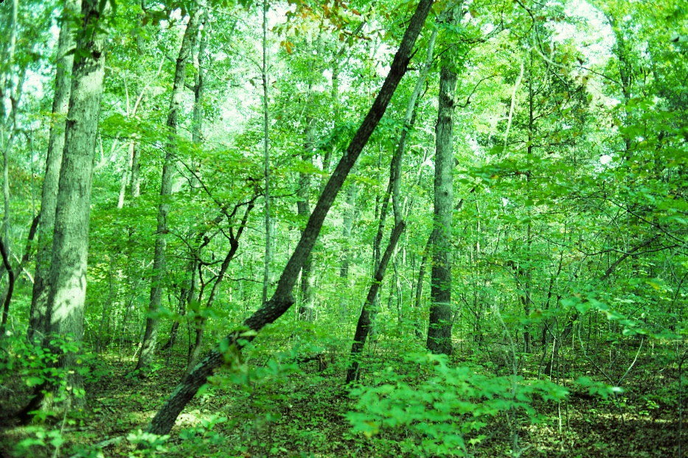
c. 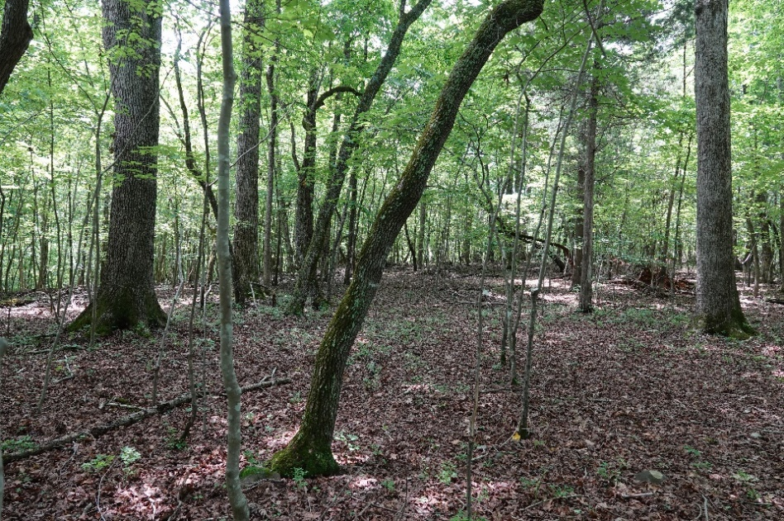
Figure 2.3. Duke Forest, Durham County, North Carolina. Three photographs taken within 5 m of the same location: (a) photo from 1936 showing pre-mesophication conditions with uneven-aged trees and oak regeneration in the understory (photo copyright Duke Forest archives), (b) photo from 1982 showing a denser canopy and vigorous regeneration of mesophytic hardwoods in the understory (photo copyright Robert Peet, (c) photo from 2020 showing a lack of oaks in the understory with many maple saplings and a depauperate herb layer due in part to increased deer browsing (photo copyright Robert Peet).

The process of mesophication seen in modern forests can be viewed as a positive feedback loop mediated by the removal of fire from the ecosystem. Lack of fire has led to increased survival of shade-tolerant, fire-intolerant tree seedlings, which have outcompeted shade-intolerant, fire-tolerant tree seedlings in the understory. A dense, mesophytic, understory creates a shadier, cooler, and moister microclimate on the forest floor, further favoring shade-tolerant mesophytic species. The litter of mesophytic trees is less flammable than oak leaves, both because it compacts and retains moisture and because it decomposes more rapidly (Kreye et al. 2013). This less flammable fuel bed reduces the probability and effectiveness of fire and so supports the continued recruitment of fire-intolerant species. There is now concern that mesophytic trees have had enough fire-free time to recruit into the canopy in greater numbers, at which point the bark of mature specimens of most species is generally thick enough to greatly reduce fire damage. These vegetation shifts are most rapid and persistent on sites that were initially more mesic, but xeric sites also exhibit mesophication (Nowacki & Abrams 2008). Even on sites with unfavorable edaphic conditions, succession may actually be taking place in the absence of fire, albeit very slowly (Abrams 1996). It should be noted that the characteristics of shade tolerance and fire intolerance crucial to the concept of mesophication are not completely coincident. Sweetgum and tulip-tree are species that are mesophytic, have fire-inhibiting litter, and are fire-intolerant, but they are not shade-tolerant. However, because their seed rain has greatly increased due to logging and fire suppression, they are more likely to occupy canopy gaps than in the past. Red maple, the species that best fits the mesophication model and appears to have increased the most in undisturbed forests, is fire-intolerant and shade-tolerant. This species is the primary focus of concern about forest changes precisely because of its broad environmental tolerances, rather than any specific preference for mesophytic sites.
While most studies of the reduction in oak dominance in Eastern forests focus on the role of fire, it is likely that several other interacting factors are also at play (Nowacki & Abrams 2015). A number of other environmental changes took place in the years marking the beginning of a decline in oak regeneration. During the last century, the eastern United States saw an increase in precipitation and a decrease in frequency and severity of drought periods (McEwan et al. 2011). Periods of drought favor stress-tolerant oaks and limit maple recruitment, even in the absence of fire. White-tailed deer populations exploded during the late 20th century because of reduction in large predators, suburbanization, and decline in hunting pressure, dramatically increasing the role of herbivory in limiting oak seedling growth (McEwan et al. 2011). However, deer appear to be affecting most tree species in the understory equally, and the initial decline in oak regeneration predates the population explosion of deer.
It is now widely believed that, for much of the Piedmont, both the original oak-hickory forest and the increasingly prevalent mesophytic forest represent potentially stable states, and that short-term restoration of the historical fire regime is not sufficient to restore the oak-hickory forest. Mesophytic litter reduces fire effectiveness while heavier shade reduces the amount of more flammable grasses. Once well established, even in the understory, mesophytic trees continue to sprout after being top-killed by fire. A single surface fire seldom kills many mature trees, even those of fire-sensitive species, so a mesophytic forest could persist through multiple fires. It must be noted, however, that infrequent fire does not resemble the historical fire regime, and that recovery of forest composition may be expected to require a long period of chronic fire. It may be better to regard the mesophytic canopy as the stable state under the current minimal fire regime and oak as the stable state under long-term periodic fire, with both states slow to equilibrate to a new regime. Oaks are long-lived trees, and any canopy gap filled by an oak is occupied for a long time. This trait helped to maintain a predominantly oak canopy until humans began to remove mature trees in large numbers. In the absence of logging or local catastrophic disturbance, the replacement of oaks in the canopy by mesophytes will take many years. Nevertheless, the reduction in oak regeneration below the shady, humid, mesophytic understories will continue to lead in the direction of oak declines if fire does not again become a regular occurrence
While the U.S. Forest Service’s understanding and acceptance of the important role of fire on the landscape began to shift at the end of the 20th century, a broad, regional approach to fire management in the southern Piedmont has not been developed, let alone implemented. Prescribed fire remains a tool used on a local basis for specific, usually short-term management goals. The land management community has taken decades longer to recognize the role of fire in oak forests than in the longleaf pine forests of the Coastal Plain. Moreover, the highly-fragmented landscape, widespread suburban and rural habitation, dense road network, and presence of cities with air quality concerns will act counter to natural wildfire, which is generally unappealing to the human population across much of the region.

2.5 Prescribed Fire and Forest Management
Despite decades of active fire exclusion, the southeastern USA has become a leader in prescribed burning over the last decade. The Southeast region overall represented 67% of the total prescribed burn area within the USA in 2017, most of it in the Coastal Plain (Melvin 2018). About three-quarters of the total area burned in the Southeast was for forestry and conservation-related purposes, with the remainder relating to agriculture. Florida alone accounted for more than a million of the 2.3 million hectares burned in the Southeast for forestry purposes. Because Coastal Plain fire regimes are generally better understood (see Chap. 3) than those of the Piedmont and the requisite return intervals are shorter, it stands to reason that the bulk of prescribed fires take place in that region.
Historical fire frequencies were much higher than those observed presently for nearly all of the Piedmont, but prescribed fire has become a useful tool to supplement management of specific Piedmont forest and woodland sites. Prescribed fire in the Piedmont is conducted on public lands for a variety of reasons. Fuel reduction is a common goal, as part of efforts to reduce the risk of future wildfire. Fire is used for site preparation before or after timber harvest and to enhance the value of future timber harvests by reducing competition from non-crop vegetation. The promotion of game animal habitat for improved hunting is another reason for many burns. Restoration of historical natural vegetation, such as the rare woodland or savanna communities of specialized edaphic settings, or for rare plants, is often the goal for burning by conservation organizations, but such management is limited to small areas and is seldom applied to larger expanses of more typical natural forest.
Land managers who use prescribed fire in the modern Piedmont usually burn during the dormant season, in part to reduce the impact on nesting and breeding wildlife, but largely due to legal, logistical, and weather constraints that make summer and fall burns more challenging (Knapp et al. 2009). Late winter and early spring are preferred by most managers for prescribed fire, and burn days are restricted to relatively humid, low-wind weather. When weather conditions are too dry and windy, the risk of fire escape becomes too high to proceed. The need for burns to be effective further limits the range of suitable weather. If humidity is too high, planned burns are often cancelled because the fire will not spread or consume enough fuel. In the dense forests of the present day, humidity beneath the canopy is typically high when trees are fully leafed out, making most summer burns less effective. Similarly, because good smoke dispersal is needed, winds can be too low during summer to proceed with a prescribed fire.
One of the early uses of prescribed fires in the Piedmont was the promotion of wildlife habitat. Piedmont forests support several game species that have been monitored and managed for decades. Several of these species, notably white-tailed deer, cottontail rabbit (Sylvilagus floridanus), and upland gamebirds, prefer heterogeneous forested habitats, including woodlands and forest edges. While deer seem largely indifferent to fire itself in the southeast, game managers follow the Native American example of maintaining clearings and meadows to attract the animals, sometimes using fire. Wild turkeys (Meleagris gallopavo) in particular benefit from a patchwork of habitats, both open- and closed-canopy, to support their foraging and nesting habits, respectively. Mourning doves (Zenaida macroura) and northern bobwhite quail (Colinus virginianus) also prefer open vegetation within a mosaic of woodland and grassland. While managers of public game lands often prepare fields for hunting by planting seed crops such as corn and millet, a mixture of native grasses and herbs is preferred by doves and quail for breeding habitat. The American woodcock (Scolopax minor) requires patches of open, grassy habitat near brushy cover for the males’ spring breeding displays, and females prefer to nest in shrubby cover near the male display grounds. Prescribed fire, usually in the late winter or spring, can be used to maintain open areas for both game species and other wildlife. These early season burns do not encompass the likely historical diversity of burn seasonality, which included fires during different seasons and under different weather conditions. Winter and spring burns, however, do help prevent woody species from invading open-canopy woodlands and savanna.
In addition to gamebirds, other native birds have preferences for open vegetation. Several raptor species, including the American kestrel (Falco sparverius) and sharp-shinned hawk (Accipiter striatus), prefer forest edges and mixed woodland as hunting habitat. Most edge species, however, have experienced a dramatic range expansion due to forest fragmentation and the addition of suburban landscaping to their potential habitat. Forest interior birds that breed in the Piedmont, particularly several species of neotropical migrants, have seen population declines due to increasing edge habitat that introduces mammalian predators and nest parasites into their breeding areas. Many of these species, such as the red-eyed vireo (Vireo olivaceus) and hooded warbler (Setophaga citrina), prefer mature forest with plentiful small, natural openings and a heterogeneous understory for nesting. This type of varied structure is produced by natural small canopy gaps in mature forest, but fire at moderate frequency is not detrimental to it. More extreme methods of opening forested habitats, particularly cutting, may instead inadvertently produce clearings that are too large, creating additional edge habitat that disrupts the breeding territories of those forest interior birds. While there has been some concern that active burning in the Piedmont might have a detrimental effect on some wildlife, particularly small mammals and herpetofauna, studies in the neighboring Appalachian and Central Hardwood regions suggest this worry is unwarranted (Harper et al. 2016, Greenberg et al. 2018, also see Chaps. 2, 4).
Several prairie bird species are found uncommonly in the southern Piedmont and only in larger open grassland or savanna habitats such as open fields, meadows, and crop land. These include dickcissel (Spiza americana), loggerhead shrike (Lanius ludovicianus), grasshopper sparrow (Ammodramus savannarum), and eastern meadowlark (Sturnella magna), all of which have been in decline over the last century. With the decline of agriculture throughout the Southeast, suitable habitat has substantially diminished. With sufficient fire frequency, grassy vegetation can be maintained as habitat for these prairie species. However, it remains unclear whether prairie bird species were residents of the Piedmont before widespread agriculture; their departure may simply be a contraction to their historical range.
Though use of fire for wildlife management usually focuses on vegetation structure, the decline of oaks due to fire suppression is also detrimental to wildlife. Annual acorn yield influences the population dynamics of dozens of mammal species, ranging from mice (Peromyscus spp) to black bears (Ursus americanus) as well as deer and turkeys (Rodewald 2003). Rodewald also notes that oak species have particular traits that are of importance to a variety of wildlife species. Acorns are more nutritious than maple fruits and the thick pericarp of acorns allows them to last longer as cached food. Deeply furrowed oak bark provides more niches for bark arthropods and the thick oak litter layer provides more habitat diversity than compact maple leaves for litter arthropods. Oaks support much larger numbers of spring Lepidopteran larvae than do maples, and these larvae are critical food sources for breeding birds. Rodewald and Abrams (2002) compared several mature forest sites in central Pennsylvania and found that both the abundance and diversity of bird communities in oak-dominated forests were 50-200% greater than those in comparable sugar maple-dominated forests. Similar disparities between oak-hickory forests and those with less oak dominance likely occur in the southern Piedmont region.
Given that oaks are both commercially valuable as timber and ecologically valuable for wildlife, reduced oak regeneration is of great concern to forest managers. As previously discussed, fire is now viewed as useful in encouraging the regeneration of oak species in Piedmont forests. Managing forests for sustained timber harvest is particularly challenging, because oaks must regenerate evenly after logging, at the same time that much or all of the seed source is being removed and the environment made more conducive for both undesirable, early successional tree species and already-established understory species. Shelterwood methods have been used for many years in attempts to encourage oak regeneration (Loftis 1990), but combining this strategy with carefully timed prescribed fire appears to be more successful. Standard shelterwood methods may promote faster-growing, ruderal species over oaks when conducted as the sole silvicultural method. Once the oak seedlings have reached a competitive size and after the final canopy tree harvest, understory release burns are used to remove undesirable mesophytic species from the understory and allow shade-intolerant oak saplings to thrive (Brose 2014). The release burns may be repeated at the desired intervals until the young oaks have reached a height where competing species will not overtop them.
Early research on the use of prescribed fire to promote oak regeneration began in the 1970s, but was dominated by several single-burn studies that found fire actually reduced oak regeneration, sometimes in favor of competing species like maples (Brose 2014). The results of these early studies are attributed to burning oak seedlings and sprouts that were too young and stunted by dense shade to survive the fire, and failure to account for the effects of fire seasonality and excessive white-tailed deer browsing in post-burn sites. The sites of studies from the 1970s and 1980s that Brose (2014) reviewed also underwent substantial thinning of mature trees prior to burning, favoring opportunistic incursions by early successional species and obscuring the impact of the fires. Subsequent studies through the 1990s have focused on mimicking natural fire regimes by focusing on return intervals and fire seasonality (Brose 2014).
By the 2010s, guidelines had been developed for the use of prescribed fire at various stages of oak forest management. To start the regeneration process in forests with little oak reproduction, seedbed preparation burns can create conditions that promote the establishment of healthy oak seedlings. Moderate intensity surface fires kill competing vegetation and remove undesirable mesophytic seedlings, while reducing the depth of the litter or exposing the mineral soil to promote acorn establishment (Brose 2014). The fire treatment may need to be repeated over more than one year before conditions are ideal for oak seedlings. Once the seedling cohort is sufficiently well-established, fire is withheld to protect the seedlings during their early growth. While shelterwood-burn techniques have seen increased popularity in recent years, it is not yet clear how effective they are.
In addition to wildlife and timber production, fire is used to manage for rare plant species and more natural vegetation and ecosystems on conservation lands. The Piedmont has fewer rare plant species than adjacent regions, but a large portion of its rare species is dependent on open, sunlit habitat. Examples include the federally listed smooth coneflower (Echinacea laevigata) and Schweinitz’s sunflower (Helianthus schweinitzii), along with even rarer species such as oak barrens Barbara’s-buttons (Marshallia legrandii), all endemic to the southern Piedmont. Additional species, such as prairie dock (Silphium terebinthinaceum), are common in grasslands west of the Appalachians but occur as rare species in the Piedmont. Most of these rare plants are associated with soils or substrates that supported naturally open vegetation. While sparsely vegetated communities, such as rock outcrops, cannot carry fire effectively and remain open in its absence, many of these specialized communities have a significant dependence on fire over the long term, and they can become denser or lose their distinctive character in its absence. The absence of specialist species away from their distinctive soils or site conditions suggests that they were not formerly widespread in the Piedmont, even during the presettlement fire regime. A few rare plant species of open habitat, such as Schweinitz’s sunflower, are less obviously strongly tied to unusual site conditions and may have been more widespread within their narrow range. Though, for the most part, it appears that rare plant species in Piedmont pyrophytic communities are more likely heliophytes than they are obligate pyrophytes, it also appears that fire was crucial for maintaining suitable habitat for them. With the long absence of fire, most sites have become too densely vegetated to support these rare species, and such heliophytes persist only in artificially maintained openings such as roadsides and power-line rights-of-way (ROWs). Fire is being used in a number of such conservation sites to maintain populations and to restore adjacent habitat.
Nearly all of the Piedmont prairie and open savanna described by early European explorers has vanished. To the extent that they represented abandoned fields and areas of intense native human land use, most would have quickly been replaced by the fields and towns of the later settlers. Other open vegetation, much of it on sites less suited to agriculture and settlement, persisted longer after Euro-American settlement but has declined in more recent decades owing to the absence of fire. Even in naturally open communities, fire served to prevent invasion by woody plants and encourage the growth of fire-tolerant herbs, particularly graminoids. Although edaphic woodlands and glades are better able to resist invasion by weedy hardwoods, it appears that, without fire, most will eventually succeed to forest (Abrams 1996). Prescribed burning is being used in some of these sites to restore more natural conditions and improve habitat for rare plants.
The Picture Creek Diabase Barrens, in Granville County, North Carolina, is an example of the possibilities and difficulties in attempting to restore a natural edaphic woodland. It became a site of interest when a large population of the federally threatened smooth coneflower was discovered along a powerline ROW, along with numerous other rare species of prairie affinities. The surrounding area, abandoned from woodland grazing and cultivation around World War II, remained somewhat open but was largely devoid of the rare species. Enough old trees remained that a dendrochronology study (Sigmon-Chatham 2015) was able to determine the species composition and basic spatial arrangement of a former open-canopy post oak and shortleaf pine woodland 100+ years ago. The site had seen an abrupt transition from regeneration of these species to establishment of loblolly pine and white oak at the time when burning presumably ceased. Several prescribed burns done inconsistently over a period of about 25 years were not adequate to improve habitat conditions (Figure 2.4b). The current management plan for approximately 24 hectares of dry-mesic basic oak-hickory forest and xeric hardpan woodland in the northeastern corner of the site involves more intensive treatment to create an open canopy structure. The ultimate goal for this management plan is to create a woodland structure that can be maintained solely through prescribed fire (Figure 2.4a). An initial timber harvest in 2014 removed all loblolly, red maple, and most of the mesophytic species in the canopy, and nearly all of the hardwood midstory (Figure 2.4c). Spot-treatment of resprouting trees with herbicide helped to slow regrowth of red maple and sweetgum in the understory. Prescribed burns every three years have since suppressed subsequent mesophytic hardwood and loblolly pine regeneration. Managers intend to increase the fire frequency to every 1-2 years for the next decade, to finish removal of undesirable resprouting trees. Several acres were invaded by non-native mesophytic grasses and saw rapid establishment of ruderal herbs, but there was also a rapid expansion of a few of the characteristic herbs of the community and increased cover of characteristic herbs where they had already existed. Expansion of the rare plants and diverse grassland assemblage from the ROW into the woodland has been limited but can be expected to continue if regular burning is maintained. There continues to be resprouting of weedy hardwoods like red maple and sweetgum, but progress is being made in their removal. The current lack of xerophytic oak regeneration is a concern, but managers plan to reduce the fire frequency once they have the weedy species under control with the expectation that this should allow oak seedlings time to fully establish (David Schnake, personal communication).
a. 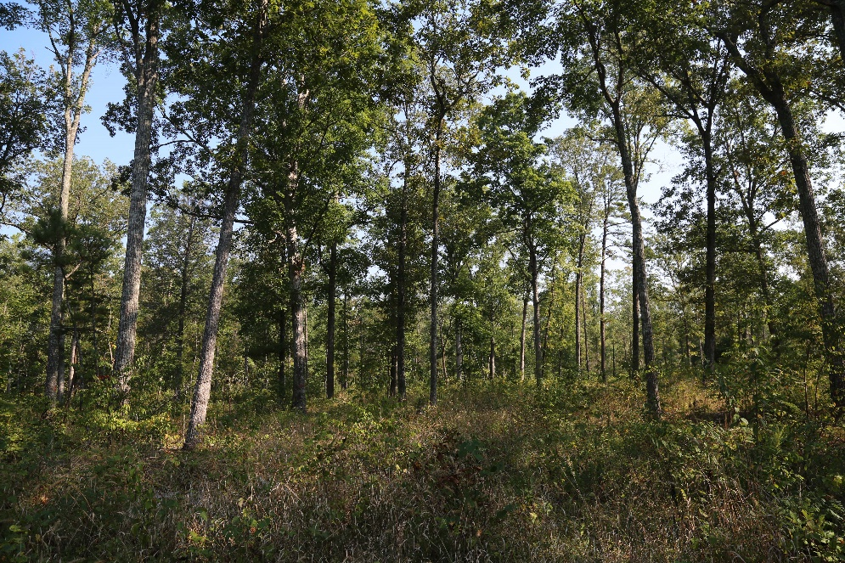
b. 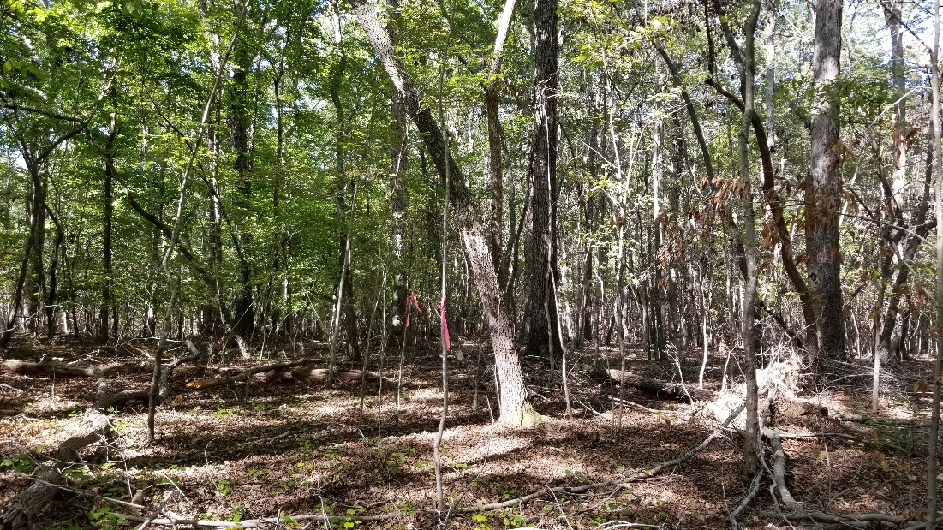
c. 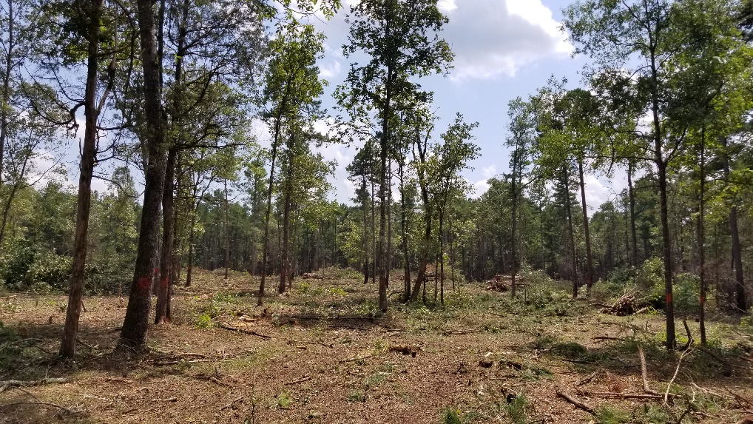
Figure 2.4. Picture Creek Diabase Barrens restoration. (a) Target vegetation with a restored open canopy of post oak and shortleaf pine and a diverse herb layer characteristic of the site’s extreme soils. (b) Preexisting degraded forest vegetation with a dense canopy of mixed hardwoods and a lack of well-developed herb layer. (c) Site after timber harvest and mechanical removal of dense understory trees, showing both resprouting hardwoods and a slowly recovering herb layer. From this point, fire will be the main tool to maintain the open vegetation (all photos copyright Robert Peet).
A few other attempts have been made to restore open edaphic woodlands in areas where rare plants persist on roadsides. Most were less thoroughly documented than the effort at the Picture Creek Diabase Barrens, but many show the slow pace of spread by conservative rare plants, and also how rapidly progress is lost if prescribed burning is not sustained. More extensive research on oak woodland restoration has taken place west of the Appalachians (e.g. Peterson & Reich 2001, Knapp et al. 2015; Chap. 4), where the climate is drier and open oak woodlands may have been a more widespread part of the natural landscape. In contrast, published research on the use of fire to restore natural open-canopy oak communities of the Piedmont is largely absent, but local land managers have been experimenting with fire on sites with unusual edaphic conditions and preexisting open characteristics.
In addition to remnants of edaphic woodlands, there are a variety of open areas on more common soil types in the Piedmont that have been maintained in open vegetation by mowing for long periods, including roadsides, powerline ROWs, areas around broadcasting towers, and long-used hay fields (e.g. Tompkins et al. 2010, Adams 2012). While few support the rarer species, and many are dominated by ruderal and exotic species, some support a diverse native flora of species that represents the diversity of heliophytic Piedmont herbs. These species likely were once much more widespread in the landscape, but it remains unclear whether these places represent remnants of prehistoric open grasslands, samples of the herb layer of regularly burned forests, or the accumulated concentration of species in an optimal artificial habitat. These are sometimes regarded as prairie remnants but generally little or nothing is known of their earlier history or vegetation. These areas are under threat as roads are widened, land is developed, and ROWs are increasingly maintained by herbicide rather than mowing (Noss 2012). Prescribed fire has been attempted in a few of these sites in the interest of promoting more natural vegetation or reducing maintenance costs.
There has also been interest in “restoring” open oak woodlands and prairies on sites with ordinary soil and no known history of past open structure or composition. Given the uncertainties about the presettlement vegetation in the Piedmont away from native villages, it is unclear if such treatments represent restoration or creation of novel artificial habitats. While heavy thinning and burning will create open conditions and typically produces an herbaceous response, the herbaceous composition is generally not reported, and is likely dominated by ruderal species rather than the desired diverse grassland flora characteristic of a presettlement landscape. These “restoration” projects may result in a superficial structural resemblance to edaphically open habitats, but not necessarily to historic or natural vegetation composition for that site.
Several generalizations regarding Piedmont oak-hickory forest management are clear. Without a change from the current unburned conditions, even examples in protected natural areas will eventually lose their oak canopy, which will be replaced by maple and/or other mesophytic species. Herbaceous diversity in forests, and the animal diversity that accompanies it, will remain low or decline further. We know enough about historic fire regimes to be confident that repeated burning at 5-10 year intervals would move forests toward a state that more closely resembles historical Piedmont forests and woodlands before human intervention. We know that substantial canopy reduction is likely to favor ruderal species and already-established species, rather than oaks or grassland herbs. We know that the resilience of invading tree species such as red maple will make restoration difficult or slow. Burning at more frequent intervals for a time may help limit regrowth of mesophytic species. Selective removal of mesophytic species, by cutting, girdling, or targeted herbicide use, may speed the process. We know that even with improved habitat conditions, the desired herbaceous species will likely be slow to establish.
2.6 Conclusion and Future Research Needs
While forest rather than woodland or savanna has been the dominant vegetation of the Piedmont for at least 10,000 years, historical forests were more open than those we see today. Details of presettlement forest communities, especially away from the Native American villages and trails, are not well known, but we can assume that fire maintained a more open structure than what is seen in modern forests. Fire would have especially limited understory trees and confined mesophytic tree species to mesic sites. The open-canopy, chronically-burned, upland Piedmont forests supported a variety of widespread herbaceous species, some of which are now considered rare. The greatest species diversity, however, has always been on smaller patches of vegetation tied to rarer edaphic conditions that succeed to forest much more slowly or not at all, even in the absence of fire. Descriptions of open forests, woodlands and savannas from early European visitors to the Piedmont are also insufficient to differentiate between naturally open vegetation and areas undergoing early succession after clearing by Native Americans. Without this information, it is difficult to estimate exactly how open this historical landscape truly was, nor how much was natural or persistent open vegetation and how much was short-lived successional vegetation of abandoned fields and depopulated villages.
Within the upland oak-hickory forests of the Piedmont, the historical role of fire is fairly clear. Fire was a frequent, low-intensity disturbance in historic and prehistoric upland forests. The challenge of staving off long-term mesophication in modern oak forests, however, is more complicated than simply understanding the historical fire regime. The current overabundance of ruderal, mesophytic, or generalist trees in the understory appears to be a legacy of large-scale land abandonment after agriculture and logging, with associated loss of chronic fire, as well as the major disturbances of modern land development. While oaks are long-lived and will remain canopy dominants for decades, continued failure of oak regeneration in the absence of fire will ultimately change the character of Piedmont forests. A sustained increase in fire frequency in Piedmont forests would help promote the dominance of oaks. It may be possible that re-implementing an historic fire frequency could promote oak regeneration and continued dominance in the canopy over time. It will, however, likely take many years or decades for fire to remove mesophytic species from the understory. Herbaceous recovery to historic composition and extent seen in open landscapes is likely to be particularly slow, due to slow spread of characteristic species, especially when seed sources are distant or absent.
Research is needed on how best to promote oak regeneration with less invasive management techniques. Current oak regeneration research is dominated by silvicultural studies that may not offer the best techniques for natural areas or wildlife management. Because major modern disturbances like clearcuts and standard shelterwood cutting seem to be promoting ruderal species at the cost of oak regeneration, other management techniques are needed to maintain natural forests. More research is needed to determine what management treatments best promote herbaceous plant diversity and oak regeneration without contributing to the invasion of mesophytic and ruderal species. It is clear that factors other than fire exclusion also affect Piedmont forest structure, including excessive deer browsing and abundant seed rain from ruderal tree species; these factors present a challenge to forest restoration efforts. There have been no long-term studies of regular prescribed fire in Piedmont that go beyond three burns over ten years (Waldrop et al. 2016). There have also been no studies of regular prescribed fire with the express goal of monitoring Piedmont oak regeneration, nor any Piedmont studies of the interactions between fire and natural canopy gap formation. Without this type of research, we cannot untangle the effects of fire from other silvicultural treatments or ecological variables.
Prescribed fire is currently used to effectively maintain open Piedmont habitat for rare, heliophytic plant species and co-occurring wildlife. Areas managed in this way are small in extent, often restricted to sites with existing, edaphically-limited vegetation, but results are encouraging. The key to the successful use of prescribed fire for Piedmont forest restoration seems to be long-term commitment – maintaining an ongoing fire regime. This type of management investment requires both significant resources and public buy-in. The increasing use of prescribed fire in the Southeast does give cause for some optimism.
Ongoing and future climate change add additional unknowns for the future of Piedmont forests. While current predictions of temperature increases are generally accepted (see Chap. 12), future patterns of precipitation are less clear. In general, the Piedmont is likely to see more variation in rainfall patterns, including increases in both floods and droughts (see Chap. 12). Increased drought may favor oaks in the future, but it may also alter the timing and duration of the wildfire season, necessitating a reassessment of risk mitigation techniques such as fuel-reduction burns. In general, the Piedmont landscape is at a lower risk from climate change than other parts of the southern USA; both development and logging rank as more significant threats to Piedmont forests.
Balancing the land-use needs of the current human population with the fire management of Piedmont forests will remain an ongoing challenge. Frequent fire was possible when the Piedmont human population was small and settlements were scattered, as was the case before and initially after Euro-American settlement. The modern human population of the Southeast is growing rapidly, and new realities make the problem of smoke and the risks of fire more problematic. Public perception plays a significant role in how and where prescribed fire is applied; normalizing prescribed fire will be critical if it is to see more widespread use. This evolving context may require novel management solutions that extend beyond the large tracts of forest managed by public institutions. Collaborative research among parties with complementary goals such as conservation, forestry, and game management is increasingly common and critical. Despite an imperfect understanding of the role of fire in the presettlement landscape, we have a clear need to define a new and long-term role for fire in Piedmont forests.

References
Abrams MD (1992) Fire and the development of oak forests. BioScience 42(5):346-353
Abrams MD (1996) Distribution, historical development and ecophysiological attributes of oak species in the eastern United States. Ann Sci Forest 53(2-3):487-512
Abrams MD (1998) The red maple paradox. BioScience 48(5):355-364
Abrams MD (2003) Where has all the white oak gone? BioScience 53(10):927-939
Adams, NS (2012) A synthesis of rights-of-way native plant communities: identifying their relevance to historical and contemporary piedmont savannas. MS Thesis, University of North Carolina, Chapel Hill, NC.
Barden LS (1997) Historic prairies in the Piedmont of North and South Carolina, USA. Nat Area J 17(2):149-152
Beverley R (2013) The History and Present State of Virginia: A New Edition with an Introduction by Susan Scott Parrish. University of North Carolina Press, Chapel Hill, NC
Billings WD (1938) The structure and development of old field shortleaf pine stands and certain associated physical properties of the soil. Ecol Monog 8(3):437-500
Braun EL (1950) Deciduous forests of eastern North America. Blackiston Co., Philadelphia
Brose PH, Van Lear DH (1998) Responses of hardwood advance regeneration to seasonal prescribed fires in oak-dominated shelterwood stands. Can J Forest Res 28(3):331-339
Brose PH (2014) Development of prescribed fire as a silvicultural tool for the upland oak forests of the eastern United States. J Forest 112(5):525-533
Catesby M (1771) The Natural History of Carolina, Florida and the Bahama Islands. Vol I
Christensen NL (1977) Changes in structure, pattern and diversity associated with climax forest maturation in Piedmont, North Carolina. Am Midl Nat 97(1):176-188
Cowell CM (1995) Presettlement Piedmont forests: patterns of composition and disturbance in central Georgia. Ann Assoc Am Geogr 85(1):65-83
Coughlan MR, Nelson DR (2018) Influences of Native American land use on the Colonial Euro-American settlement of the South Carolina Piedmont. PloS One 13(3)
Cumming, WP (1986) The Southeast in early maps. Third edition. University of North Carolina Press, Chapel Hill, NC
Davis JE Jr, McRae C, Estep BL, Barden LS, Matthews JF (2002) Vascular flora of Piedmont prairies: evidence from several prairie remnants. Castanea 67(1):1-12
Delcourt PA, Delcourt HR (2004) Prehistoric native Americans and ecological change. Cambridge University Press. Cambridge, UK
DiPIetro JA (2013) Landscape evolution in the United States: an introduction to the geography, geology, and natural history. Elsevier, Amsterdam
Emrick V, Jones J (2008) Influence of competition on the density of the federally endangered Michaux's sumac (Rhus michauxii) at Fort Pickett, Virginia. Southeast Nat 7(1):61-8
Ferguson TA, Cowan TA (1997) Iron plantations and the eighteenth-and nineteenth-century landscape of the northwestern South Carolina Piedmont. In Stine LF, Zierden M, Drucker LM, Judge C (eds) Carolina’s Historical Landscapes: Archaeological Perspectives. University of Tennessee Press, Knoxville, TN
Flatley WT, Lafon CW, Grissino-Mayer HD, LaForest LB (2013) Fire history related to climate and land use in three southern Appalachian landscapes in the eastern United States. Ecol Appl 23(6):1250-1266
Foote WH (1846) Sketches of North Carolina, Historical and Biographical, Illustrative of the Principles of a Portion of Her Early Settlers. Robert Carter, New York.
Ford WM, Menzel MA, McGill DW, Laerm J, McCay TS (1999) Effects of a community restoration fire on small mammals and herpetofauna in the southern Appalachians. Forest Ecol Manag 114(2-3):233-243
Fowler C, Konopik E (2007) The history of fire in the southern United States. Hum Ecol Rev 14(2):165-176
Frost CC (1998) Presettlement fire frequency regimes of the United States: a first approximation. In Pruden TL, Brennan LA (eds) Fire in ecosystem management: shifting the paradigm from suppression to prescription. Tall Timbers Fire Ecology Conference Proceedings, No. 20. Tall Timbers Research Station, Tallahassee, FL
Gagnon PR (2009) Fire in floodplain forests in the southeastern USA: insights from disturbance ecology of native bamboo. Wetlands 29(2):520-6
Greenberg CH, Moorman CE, Matthews-Snoberger CE, Waldrop TA, Simon D, Heh A, Hagan D (2018) Long-term herpetofaunal response to repeated fuel reduction treatments. J Wildl Manage 82(3):553-565
Guyette RP, Muzika RM, Dey DC (2002) Dynamics of an anthropogenic fire regime. Ecosystems 5(5):472-486
Guyette RP, Stambaugh MC, Dey DC, Muzika RM (2012) Predicting fire frequency with chemistry and climate. Ecosystems 15(2):322-35
Hakkenberg CR, Peet RK, Wentworth TR, Zhu K, Schafale MP (2020) Tree cover constrains the fertility-diversity relationship across vegetation of the southeastern USA. Ecology (in press)
Hammett JE (1992) The shapes of adaptation: historical ecology of anthropogenic landscapes in the southeastern United States. Landscape Ecol 7(2):121-35
Harper CA, Ford WM, Lashley MA, Moorman CE, Stambaugh MC (2016) Fire effects on wildlife in the Central Hardwoods and Appalachian regions. Fire Ecol 12:127-159.
Harshberger JW (1911) Phytogeographic survey of North America. W. Engelmann, Leipzig
Holmes JS (1914) Forest fires in North Carolina in 1913 and state forest fire prevention in the United States. Economic Paper No. 37, North Carolina Geological and Economic Survey
Horton JW Jr, Zullo VA (eds) (1991) The Geology of the Carolinas. University of Tennessee Press, Knoxville, TN
Jones EE, Gattis M, Morrison TC, Wardner A, Frantz S (2012) Exploring Tribal Settlement Ecology in the Southeast: A Case Study from the North Carolina Piedmont, 800–1600 Ce. N Am Archaeol 33(2):159-92
Keever C (1950) Causes of succession on old fields of the Piedmont, North Carolina. Ecology 20(3):229-250
Knapp EE, Estes BL, Skinner CN (2009) Ecological effects of prescribed fire season: a literature review and synthesis for managers. USDA Forest Service, Pacific Southwest Research Station. General Technical Report PSW-GTR-224. Redding, CA
Knapp BO, Stephan K, Hubbart JA (2015) Structure and composition of an oak-hickory forest after over 60 years of repeated prescribed burning in Missouri, USA. Forest Ecol Manag 344:95-109
Knott JA, Desprez JM, Oswalt CM, Fei S (2019) Shifts in forest composition in the eastern United States. Forest Ecol Manag 433:176-183
Kressuk JM, Goode JD, Bhuta AA, Hart JL, Kleinman JS, Phillips DL, Willson KG (2020) Composition and structure of a montane longleaf pine stand on the Alabama Piedmont. Southeast Nat 19(2):436-46
Kreye JK, Varner JM, Hiers JK, Mola J (2013) Toward a mechanism for eastern North American forest mesophication: differential litter drying across 17 species. Ecol Appl 23(8):1976-1986
Lafon CW, Waldron JD, Cairns DM, Tchakerian MD, Coulson RN, Klepzig KD (2007) Modeling the effects of fire on the long‐term dynamics and restoration of yellow pine and oak forests in the southern Appalachian Mountains. Restor Ecol 15(3):400-411
Lafon CW (2016) Ice storms in central hardwood forests: The disturbance regime, spatial patterns, and vegetation influences. In Greenberg CH, Collins BS (eds) Natural disturbances and historic range of variation. Springer, Heidelberg, pp. 147-166
Lafon CW, Naito AT, Grissino-Mayer HD, Horn SP, Waldrop TA (2017) Fire history of the Appalachian region: a review and synthesis. Gen. Tech. Rep. SRS-219. Asheville, NC: US Department of Agriculture, Forest Service, Southern Research Station. 219:1-97
Lawson J (1709) A New Voyage to Carolina. London
L'Isle, GD (1718) Carte de la Louisiane et du cours du Mississipi i.e. Mississippi: dressée sur un grand nombre de mémoires entrautres sur ceux de Mr. le Maire. Paris: Chez l'auteur le Sr. Delisle sur le quay de l'horloge avec privilege du roy. Retrieved from the Library of Congress, https://www.loc.gov/item/2001624908/.
Littell JS, Peterson DL, Riley KL, Liu Y, Luce CH (2016) A review of the relationships between drought and forest fire in the United States. Glob Change Biol 22(7):2353-2369
Loftis DL (1990) A shelterwood method for regenerating red oak in the southern Appalachians. Forest Sci 36(4):917-929
McEwan RW, Dyer JM, Pederson N (2011) Multiple interacting ecosystem drivers: toward an encompassing hypothesis of oak forest dynamics across eastern North America. Ecography 34(2):244-256
Melvin MA (2018) 2018 National prescribed fire use survey report. Technical Report 03-18. Coalition of Prescribed Fire Councils, Inc. 29 p
Noss RF (2012) Forgotten grasslands of the South: natural history and conservation. Island Press
Nowacki GJ, Abrams MD (2008) The demise of fire and “mesophication” of forests in the eastern United States. BioScience 58(2):123-138
Nowacki GJ, Abrams MD (2015) Is climate an important driver of post‐European vegetation change in the Eastern United States? Glob Change Biol 21(1):314-334
Nowak JT, Klepzig KD, Coyle DR, Carothers WA, Gandhi KJ (2016) Southern pine beetles in central hardwood forests: Frequency, spatial extent, and changes to forest structure. In Greenberg CH, Collins BS (eds) Natural disturbances and historic range of variation. Springer, Heidelberg, pp. 73-88
Oosting HJ (1942) An ecological analysis of plant communities of Piedmont, North Carolina. Am Midl Nat 28(1):1-126
Orwig DA, Abrams MD (1994) Land-use history (1720–1992), composition, and dynamics of oak–pine forests within the Piedmont and Coastal Plain of northern Virginia. Can J Forest Res 24(6):1216-1225
Orville RE, Huffines GR, Burrows WR, Cummins KL (2011) The North American lightning detection network (NALDN)—Analysis of flash data: 2001–09. Mon Weather Rev 139(5):1305-22
Patterson TW, Knapp PA (2016) Observations on a rare old-growth montane longleaf pine forest in central North Carolina, USA. Nat Area J 36(2):153-161
Peet RK, Christensen NL (1980) Succession: a population process. In Succession (pp. 131-140). Springer, Dordrecht
Peet RK, Palmquist KA, Tessel SM (2014) Herbaceous layer species richness of southeastern forests and woodlands: Patterns and causes. In Gilliam FS (ed) The herbaceous layer in forests of eastern North America, Second edition. Oxford University Press, Oxford, UK. pp. 255-276
Peterson CJ, Cannon JB, Godfrey CM (2016) First steps toward defining the wind disturbance regime in central hardwoods forests. In Greenberg CH, Collins BS (eds) Natural disturbances and historic range of variation. Springer, Heidelberg, pp. 89-122
Peterson DW, Reich PB (2001) Prescribed fire in oak savanna: fire frequency effects on stand structure and dynamics. Ecol Appl 11(3):914-27
Rodewald AD, Abrams MD (2002) Floristics and avian community structure: implications for regional changes in eastern forest composition. Forest Sci 48(2):267-272
Rodewald AD (2003) Decline of oak forests and implications for forest wildlife conservation. Nat Areas J 23(4):368-371
Rostlund E (1957) The myth of a natural prairie belt in Alabama: an interpretation of historical records. Ann Assoc Am Geogr 47(4):392-411
Schafale MP (2012) Guide to the natural communities of North Carolina, fourth approximation. NC Department of Natural Resources, Natural Heritage Program
Sigmon-Chatham LL (2015) Historic forest structure and composition of the dry mesic basic oak-hickory and xeric hardpan forest community types of the Picture Creek diabase barrens: Insights from dendrochronology. M.S. Thesis. North Carolina State University, Raleigh, NC. 182 pp
Still CJ, Cotton JM, Griffith DM (2019) Assessing earth system model predictions of C4 grass cover in North America: From the glacial era to the end of this century. Global Ecol Biogeogr 28 (2):145-157
Stokes TA, Samuelson LJ, Kush JS, Farris MG, Gilbert JC (2010) Structure and diversity of longleaf pine (Pinus palustris Mill.) forest communities in the Mountain Longleaf National Wildlife Refuge, northeastern Alabama. Nat Area J 30(2):211-225
Szakacs AD (2020) Using Multiple Approaches to Explore the Past and Present of “Piedmont Prairie” Vegetation. Doctoral Dissertation, NCSU
Tompkins RD, Lukenbaugh CM, Stringer WC, Richardson KH, Mikhailova EA, Bridges SC Jr. (2010) Suther Prairie: Vascular flora, species richness and edaphic factors. Castanea 75(2):232-244
Trimble SW (1974) A volumetric estimate of man-induced soil erosion on the southern Piedmont Plateau. In Present and prospective technology for predicting sediment yields and sources. U.S.D.A. Agricultural Research Service ARS-S-40
Turck JA, Williams M, Chamblee JF (2011) Examining variation in the human settlement of prehistoric Georgia. Early Georgia 39(1):5-26
U.S. Environmental Protection Agency (2013) Level III ecoregions of the continental United States: Corvallis, Oregon, U.S. EPA – National Health and Environmental Effects Research Laboratory, map scale 1:7,500,000, https://www.epa.gov/eco-research/level-iii-and-iv-ecoregions-continental-united-states
Van Wagtendonk JW (2007) The history and evolution of wildland fire use. Fire Ecol 3(2):3-17
Waisanen PJ, Bliss NB (2002) Changes in population and agricultural land in conterminous United States counties, 1790 to 1997. Global Biogeochem Cy 16(4):84-1
Waldrop TA, Hagan DL, Simon DA (2016) Repeated application of fuel reduction treatments in the southern Appalachian mountains, USA: implications for achieving management goals. Fire Ecol 12(2):28–47.
Weaver JE, Clements FE (1929) Plant Ecology. McGraw-Hill Book Company, NY
Wells BW (1932) The natural gardens of North Carolina. University of North Carolina Press, Chapel Hill, NC
Williams JW, Shuman BN, Webb III T, Bartlein PJ, Leduc PL (2004) Late‐Quaternary vegetation dynamics in North America: scaling from taxa to biomes. Ecol Monogr 74(2):309-34

